“Building Bridges”
Activist Academy
Year 1
Participant Information Pack

Berlin, 17-21 July 2017

This conference is generously supported by Council of Europe’s European Youth Foundation and by partner organization and conference host Lambda Jugendnetzwerk

Welcome to IGLYO’s first edition of the Activist Academy!

We are really excited that you have accepted to be part of IGLYO’s first edition of the Activist Academy. We hope it will be a useful and memorable event. This Information Pack should contain everything you need to know about before, during and after the event. Please read it all before you attend, and if you have any questions that are not answered below, please feel free to get in touch.
Please note that the Academy agenda is still a draft and some events might be rescheduled, especially the evening program. More updated information will be available on Monday. The program consists of two main parts, the workshops and the team challenges. The workshops will take place during Tuesday and Wednesday and the team challenges during Thursday and Friday. During the team challenges part, you will be working individually and together with the rest of your team.

cONtents

- Contact Info
- Preparations
- Travel and Accommodation
- Reimbursement
- Draft program
Contact Information

If you have any questions regarding the program, travel or accommodation, please contact:

Name | Organisation | Email | Phone
Tudor Kovacs | IGLYO | tudor@iglyo.com | +40 744 870718
Nora Ellerbrock | Lambda Jugendnetzwerk | nora.ellerbrock@lambda-online.de | +49 172 8467321

You should always be able to reach someone on these numbers during the conference.
In case of any emergency during your stay in, dial 112.

PREPARATIONS

IGLYO’s events have a packed agenda and often involve working long hours. Here is a list of some things you can do in advance to help ensure you are prepared for the meeting and time is used well together:

A/ General

- Read through this information pack
- Add conference contacts to your phone before travelling

B/ What To Bring

- Suitable clothing (check weather forecast for Berlin)
- A laptop or tablet, if you have one, as this will be useful for some of the sessions
- Your European Health Insurance card, if applicable, and any other travel insurance documentation (please see below for information on IGLYO’s policy about travel insurance for conference participants)
- Any medication you may need
- All boarding passes for flights and any other travel tickets or receipts.

travel and accommodation

Hotel information:
Intercity Hotel Berlin Ostbahnhof
Am Ostbahnhof 5
10243 Berlin
Germany
https://www.intercityhotel.com/berlin/intercityhotel-berlin-ostbahnhof

How to get to the Hotel:

Information on public transport through https://www.fahrinfo-berlin.de

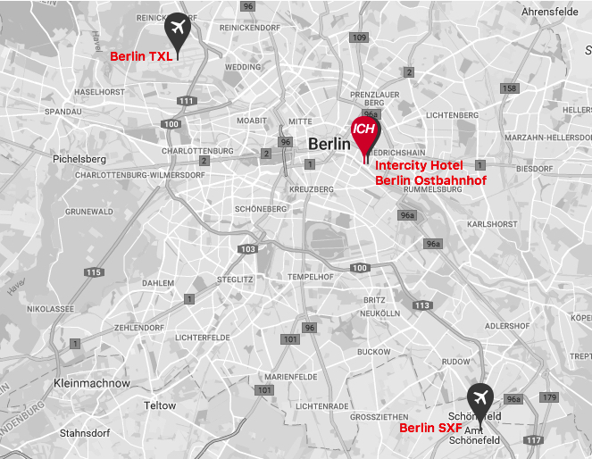

From Airport Berlin Tegel (TXL):
Buy an AB public transport ticket (2,80€), there is a machine just outside by the bus station

1/ take the bus TXL (direction Alexanderplatz) until Alexanderplatz
2/ change into any S-Bahn going east for 2 stations until Berlin Ostbahnhof

When arriving at Berlin Ostbahnhof, go to the main entrance hall. When you exit the station, go 30 meters to the left to the entrance of the Hotel.

From Airport Berlin Schönefeld (SXF):
Buy an ABC public transport ticket (3,40€), there are machines at the station before you go up on the platforms

1/ take the DB Regio train RE7 (direction Dessau) or RB14 (direction Nauen) to Berlin Ostbahnhof
OR
Take the S-Bahn S9 (direction S+U Pankow) until Berlin Ostkreuz and change there into the S-Bahn S7 (direction Postdam) until Berlin Ostbahnhof.

When arriving at Berlin Ostbahnhof, go to the main entrance hall. When you exit the station, go 30 meters to the left to the entrance of the Hotel.

From Berlin Hauptbahnhof:

Take any S-Bahn direction east for 5 stations until Berlin Ostbahnof
When arriving at Berlin Ostbahnhof, go to the main entrance hall. When you exit the station, go 30 meters to the left to the entrance of the Hotel.

OR

Take the bus 142 directin Ostbahnhof until the end, it stops just in front of the Hotel

REIMBURSEMENTS

Before posting Reimbursement Forms and receipts/boarding passes, you should send a scanned copy or photos of all documents, including the Reimbursement Form to receipts@iglyo.com.

IGLYO still needs the original paper copies too, so they should be posted to:

IGLYO
Activist Academy
Chaussée de Boondael 6
Brussels 1050
Belgium

Please make sure, that all originals arrive in IGLYO’s office no later than 25 August 2017. If you fail to provide us with the originals in time, IGLYO may not be able to reimburse you due to funding restrictions. It should be in everyone’s interest to avoid such a situation.

All accommodation and meals (from dinner on 16 July until breakfast on 22 July) are provided as part of the conference. IGLYO expects all participants to book their own travel, but can assist with this in special circumstances. Flights or other travel which costs over €300 should be approved by IGLYO before you book.

A/ Tickets & Receipts

Even if your travel was paid for by IGLYO it is essential that you keep all tickets and receipts. Boarding passes are especially important, so even if you check in online, please print a paper copy of all tickets. Failure to supply tickets or receipts will result in you being asked to pay back the amount in full.

Whenever possible, you should check in online prior to departure and save the copy of electronic boarding passes to send to receipts@iglyo.com. This ensures that the boarding passes will not be lost. Furthermore it is required to check in online by some of the budget airlines to avoid additional charges.

Reimbursement Forms and receipts should arrive in the IGLYO office within 1 month of the event. Reimbursements arriving after this date may not be processed.
For expenses claimed in currencies other than Euro, the conversion will be carried out on the basis of the official exchange rate of the Council of Europe on the date of settlement. For bank transfers, participants should clearly indicate the name and address of the bank, the IBAN, SWIFT code and name of the holder of the account.

Please note: Electronic tickets will only be considered as acceptable accompanied by a proof of payment (i.e. original invoice issued by a travel agency or airline company, copy of credit card slip, copy of bank statement showing the amount spent). You must provide an original invoice, showing the amount paid and the method of payment used. An itinerary receipt given by the airline company will not suffice, unless it is supported by a proof of payment (as indicated above).

Participants should aim to keep expenses low by:
Booking travel in advance
Researching different options to find a reasonable compromise between price and convenience

Claims shall not include:
Taxi fares (unless public transport is not available)
First class or business travel
Parking/speeding fines
Travel insurance

All claims made must be recorded on the IGLYO Reimbursement Form, signed and dated by the claimant and accompanied by receipts, which must be numbered and attached to sheets of A4, stapled behind the Reimbursement Form. All receipts must be arranged so they are fully visible.

B/ Luggage

If luggage is not included in the ticket price, you are permitted to book one item of hold luggage (smallest available). If it is a short trip, Board Members, Volunteers and Staff are encouraged to only take hand luggage when possible. Any additional items of luggage or excess luggage costs will not be reimbursed by IGLYO unless agreed with IGLYO in advance.

C/Missed travel or failure to attend

Any expense related to the conference, which is missed or not attended will not be reimbursed or will need to be paid back to IGLYO in full unless there is a valid reason.

Legitimate reasons include:
Serious illness (doctor’s note may be required)
Travel delays or cancellations without individual control

Non-legitimate reasons include:
Lateness or poor time management in relation to travel
Forgotten or lost passports/travel documents
Getting lost or lack of travel planning
Failure to check in online in advance

Reimbursements will only be processed when accompanied by receipts, tickets and boarding passes. Failure to provide these will mean your reimbursement cannot be paid.

D/ Attendance
The participants should be present for the entire session. Participants attending less than 80% of the total duration of the session will not be reimbursed
 | Monday 17.07.2017 | Tuesday 18.07.2017 | Wednesday 19.07.2017 | Thursday 20.07.2017 | Friday 21.07.2017 | Saturday 22.07.2017
09:30 - 11:00 | Welcome to the first edition of IGLYO's Activist Academy!  Go find it! - treasure hunt  - small groups - | Workshop 1: Communications for Social Change  Workshop 2: Creating Trans Inclusive Organisations  - paralel sessions -  - coffee break in the middle - | Workshop 4: Making Videos  Workshop 5: Public Speaking  - parallel sessions -  - coffee break in the middle - | Whole group morning announcements  Teams work independently | Teams presentations | Departures
11:00 - 11:30 | Coffee break
11:30 - 13:00 | My week, my team! - getting to know your team  - small groups - |  |  | Teams work independently | Teams presentations
13:00 - 14:30
14:30 - 16:00 | Typical conference introductions: objectives, expectations, logistcs, groundrules  - big group - | Workshop 3: Online Campaigning  Workshop 4: Making videos  - paralel sessions -  - coffee break in the middle - | Workshop 6: Community Organising  Workshop 7: Facilitation  - parallel sessions -  - coffee break in the middle - | Teams work independently | How about this Activist Academy?
16:00 - 16:30 | Coffee break |  |  | Coffee break
16:30 - 18:00 | Who are you, people?  - big group - |  |  | Teams work independently | The Grand Award Ceremony and saying Good-bye
18:00 - 18:45 | Home groups | Home groups | Big group home group | Home groups
19:00 - 20:00 | Dinner
20:00 - 22:00 |  | Activity with local organisation - outside the hotel |  |  | Party

About IGLYO

IGLYO began in 1984 as the International Gay & Lesbian Youth Organisation. Over the years it has evolved to become the International Lesbian, Gay, Bisexual, Transgender & Queer Youth & Student Organisation. IGLYO’s vision is:

a world where we, young people in all our diversity, are able to express and define our
own sexual orientations, gender identities and gender expressions without discrimination,
violence or hatred. We work for world where we can participate without limitation in our
lives and communities, so we can rise to our full potential, enjoying respect, celebration
and positive recognition

IGLYO has over eighty members from across the pan European region and have a Board of nine young people who are elected at our General Assembly for a two-year mandate. IGLYO also provides several other leadership and volunteering opportunities for LGBTQ youth, through prep teams, task forces, office placements, internships and event hosting. The Board and volunteers are supported by the Secretariat, which consists of two full time staff, an Executive Co-ordinator and a Capacity Buiding Officer.

IGLYO’s current priorities, as detailed in our Strategic Plan are:

- Intersectionality and diversity of LGBTQ youth communities
- Social inclusion of LGBTQ youth and students
- Education

www.iglyo.com
office@iglyo.com
www.facebook.com/iglyo
www.twitter.com/iglyo

Welcome to Berlin!

